

Data Lake and Data Warehouse
Year 2 (2025/26), Semester 4

SCHOOL OF INFOCOMM TECHNOLOGY
Diploma in Data Science

ASSIGNMENT
Part B
Individual

Module Group: | P01
Student ID: | S10267542D
Student Full Name: | Jayden Tee

Table of Contents
SCHOOL OF INFOCOMM TECHNOLOGY 1
Question 1 (15 Marks) – Individual 2
Step 1: Create a new worksheet “Jayden Tee DLW ASG – Part B Q1” 2
Step 2: Set Context and Suspend Warehouse 2
Step 3: Create New Store Procedure (SP) by modifying the existing SP in your practical 2
Step 4: Capture the screenshot of your New SP under CHIPMUNK_DB.RAW schema 3
Step 5: Paste your New SP scripts below: 3
Step 6: Refer to Appendix to check the Quarters assigned to you. Load all months under the assigned quarters from 2018 to 2021 to the stage. 4
Step 7: Paste your scripts below for creating External Table with Partition function. 5
Step 8: Capture screenshots of the query results both with and without the Partitioning function applied. Then, compare the performance or results between the two scenarios, highlighting any differences. 6
Explaination/Overview 7
Step 9: Capture screenshots of the query results both View and Materialized View function applied. Then, compare the performance or results between the two scenarios, highlighting any differences. 7
Explaination/Overview: 8
Step 10: Explore and implement additional granular partitioning schemes and demonstrate their impact on query performance. 9
Explaination/Overview 9
Question 2 (25 Marks) – Individual 10
Step 1: Create a new worksheet “Jayden Tee DLW ASG – Part B Q2” 10
Step 2: Set Context and Suspend Warehouse 10
Step 3: Understanding the purpose 10
Step 4: Pipeline Architecture (objects created) 11
Step 5: The task DAG Flow (T1 -> T2 -> T3) 12
Step 6: The key implementation details 13
1. Python UDF 13
2. Incremental Parsing Using Streams 14
3. External Table Stats (PART vs NOPART) 16
Step 7: Challenges encountered 18

Question 1 (15 Marks) – Individual

Step 1: Create a new worksheet “Jayden Tee DLW ASG – Part B Q1”
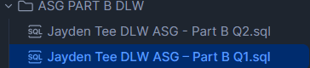

Step 2: Set Context and Suspend Warehouse
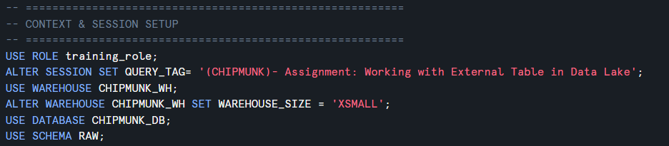
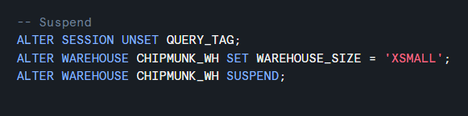

Step 3: Create New Store Procedure (SP) by modifying the existing SP in your practical
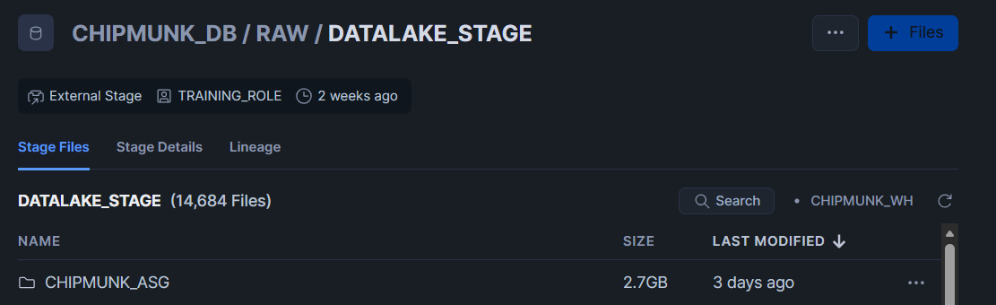

Step 4: Capture the screenshot of your New SP under CHIPMUNK_DB.RAW schema
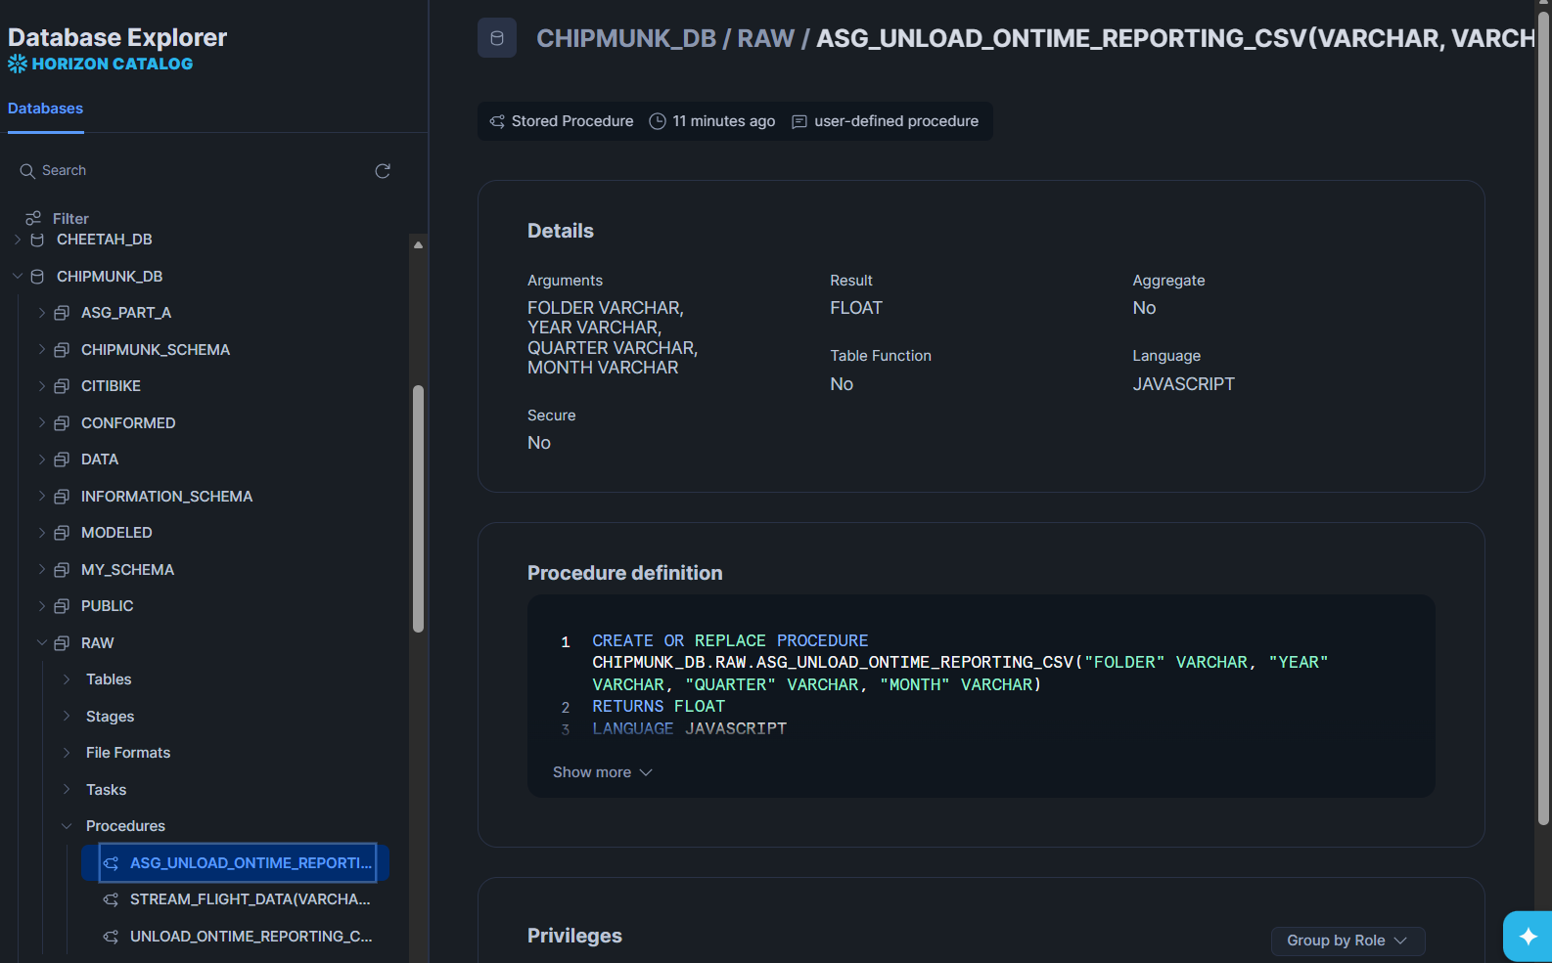

Step 5: Paste your New SP scripts below:
CREATE OR REPLACE PROCEDURE CHIPMUNK_DB.RAW.ASG_UNLOAD_ONTIME_REPORTING_CSV("FOLDER" VARCHAR, "YEAR" VARCHAR, "QUARTER" VARCHAR, "MONTH" VARCHAR)
RETURNS FLOAT
LANGUAGE JAVASCRIPT
EXECUTE AS OWNER
AS '
var unload_sql = `
COPY INTO @raw.datalake_stage/${FOLDER}/year=${YEAR}/quarter=${QUARTER}/month=${MONTH}/ontime_
FROM (
SELECT *
FROM raw.ONTIME_REPORTING
WHERE YEAR = ''${YEAR}''
AND QUARTER = ''${QUARTER}''
AND MONTH = ''${MONTH}''
)
FILE_FORMAT = (
TYPE = ''CSV''
COMPRESSION = NONE
FIELD_DELIMITER = '',''
SKIP_HEADER = 0
FIELD_OPTIONALLY_ENCLOSED_BY = ''"''
)
OVERWRITE = TRUE
`;
snowflake.execute({ sqlText: unload_sql });
return 1;
';

Step 6: Refer to Appendix to check the Quarters assigned to you. Load all months under the assigned quarters from 2018 to 2021 to the stage.
Paste all the SP calls below to load the new files to the stage.
-- ===== 2018 Q3 =====
CALL RAW.ASG_UNLOAD_ONTIME_REPORTING_CSV('CHIPMUNK_ASG','2018','3','7');
CALL RAW.ASG_UNLOAD_ONTIME_REPORTING_CSV('CHIPMUNK_ASG','2018','3','8');
CALL RAW.ASG_UNLOAD_ONTIME_REPORTING_CSV('CHIPMUNK_ASG','2018','3','9');

-- ===== 2019 Q3 =====
CALL RAW.ASG_UNLOAD_ONTIME_REPORTING_CSV('CHIPMUNK_ASG','2019','3','7');
CALL RAW.ASG_UNLOAD_ONTIME_REPORTING_CSV('CHIPMUNK_ASG','2019','3','8');
CALL RAW.ASG_UNLOAD_ONTIME_REPORTING_CSV('CHIPMUNK_ASG','2019','3','9');

-- ===== 2020 Q3 =====
CALL RAW.ASG_UNLOAD_ONTIME_REPORTING_CSV('CHIPMUNK_ASG','2020','3','7');
CALL RAW.ASG_UNLOAD_ONTIME_REPORTING_CSV('CHIPMUNK_ASG','2020','3','8');
CALL RAW.ASG_UNLOAD_ONTIME_REPORTING_CSV('CHIPMUNK_ASG','2020','3','9');

-- ===== 2021 Q3 =====
CALL RAW.ASG_UNLOAD_ONTIME_REPORTING_CSV('CHIPMUNK_ASG','2021','3','7');
CALL RAW.ASG_UNLOAD_ONTIME_REPORTING_CSV('CHIPMUNK_ASG','2021','3','8');
CALL RAW.ASG_UNLOAD_ONTIME_REPORTING_CSV('CHIPMUNK_ASG','2021','3','9');

Step 7: Paste your scripts below for creating External Table with Partition function.
CREATE OR REPLACE EXTERNAL TABLE RAW.EXTERNAL_ONTIME_ASG_CHIPMUNK_PART (
year INT AS (SPLIT_PART(SPLIT_PART(metadata$filename,'year=',2), '/', 1)::int),
quarter INT AS (SPLIT_PART(SPLIT_PART(metadata$filename,'quarter=',2), '/', 1)::int),
month INT AS (TRY_CAST(value:c3::string AS INT)), -- Month from data
day_of_month INT AS (TRY_CAST(value:c4::string AS INT)),
day_of_week INT AS (TRY_CAST(value:c5::string AS INT)),
fl_date DATE AS (TRY_CAST(value:c6::string AS DATE)),
op_carrier STRING AS (value:c9::string),
origin STRING AS (value:c15::string),
dest STRING AS (value:c24::string),
arr_delay INT AS (TRY_CAST(value:c43::string AS INT)),
cancelled INT AS (TRY_CAST(value:c48::string AS INT))
)
PARTITION BY (year, quarter)
LOCATION = @raw.datalake_stage/CHIPMUNK_ASG
FILE_FORMAT = (FORMAT_NAME = 'RAW.ONTIME_REPORTING_CSV_CHIPMUNK');

Step 8: Capture screenshots of the query results both with and without the Partitioning function applied. Then, compare the performance or results between the two scenarios, highlighting any differences.
Without Partition
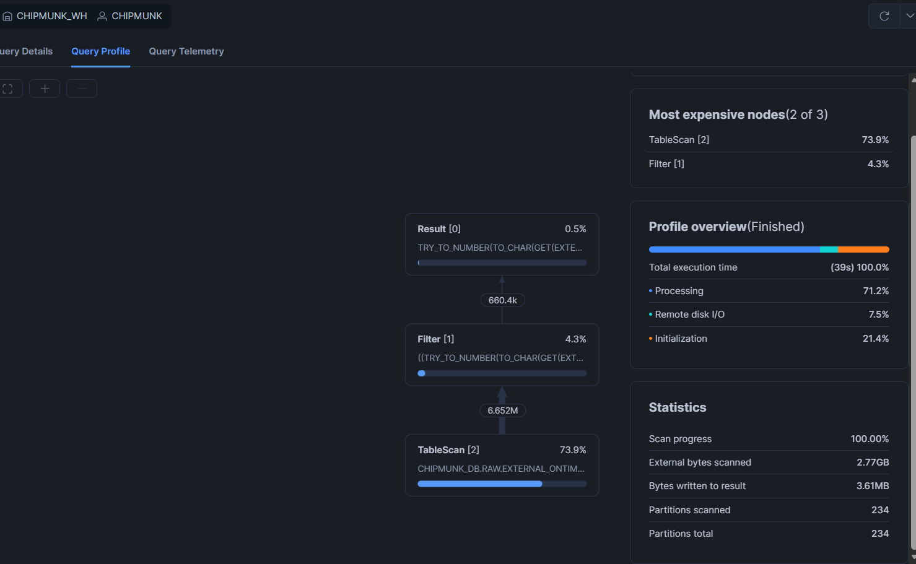
With Partition
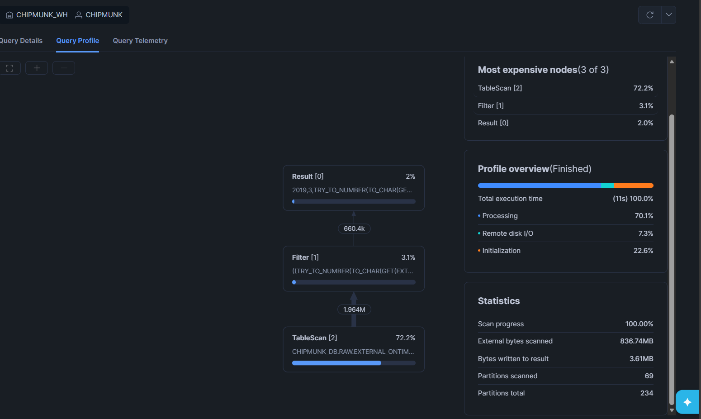

Explaination/Overview
During without partition, snowflake performed a full table scan. Hence, it had to look at every single one of the 234 partitions, which is also 2.77 GB of external bytes scanned to find the relevant data. However with partition, it only scanned 69 partitions, which is also 836.74 MB of external bytes. Hence, by pruning the other 210 partitions, Snowflake avoided reading over 2.4 GB of unnecessary data from remote storage, allowing the warehouse to process the relevant results much faster and with far less computational overhead. Additionally, the execution time without partition is 39 seconds but dropped to 11s with partition, which shows a great performance boost.

Step 9: Capture screenshots of the query results both View and Materialized View function applied. Then, compare the performance or results between the two scenarios, highlighting any differences.
View
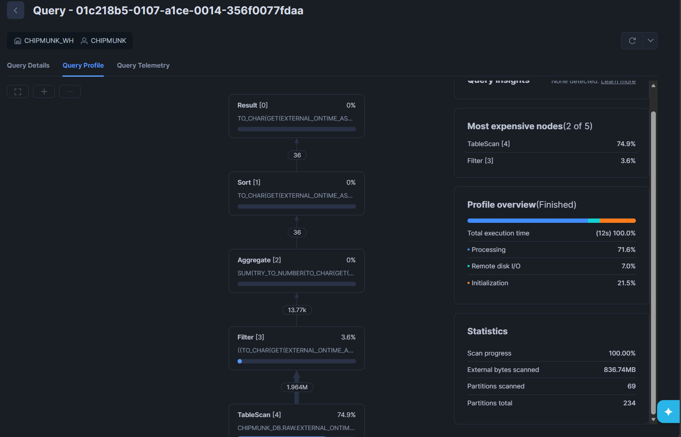
Materialized View
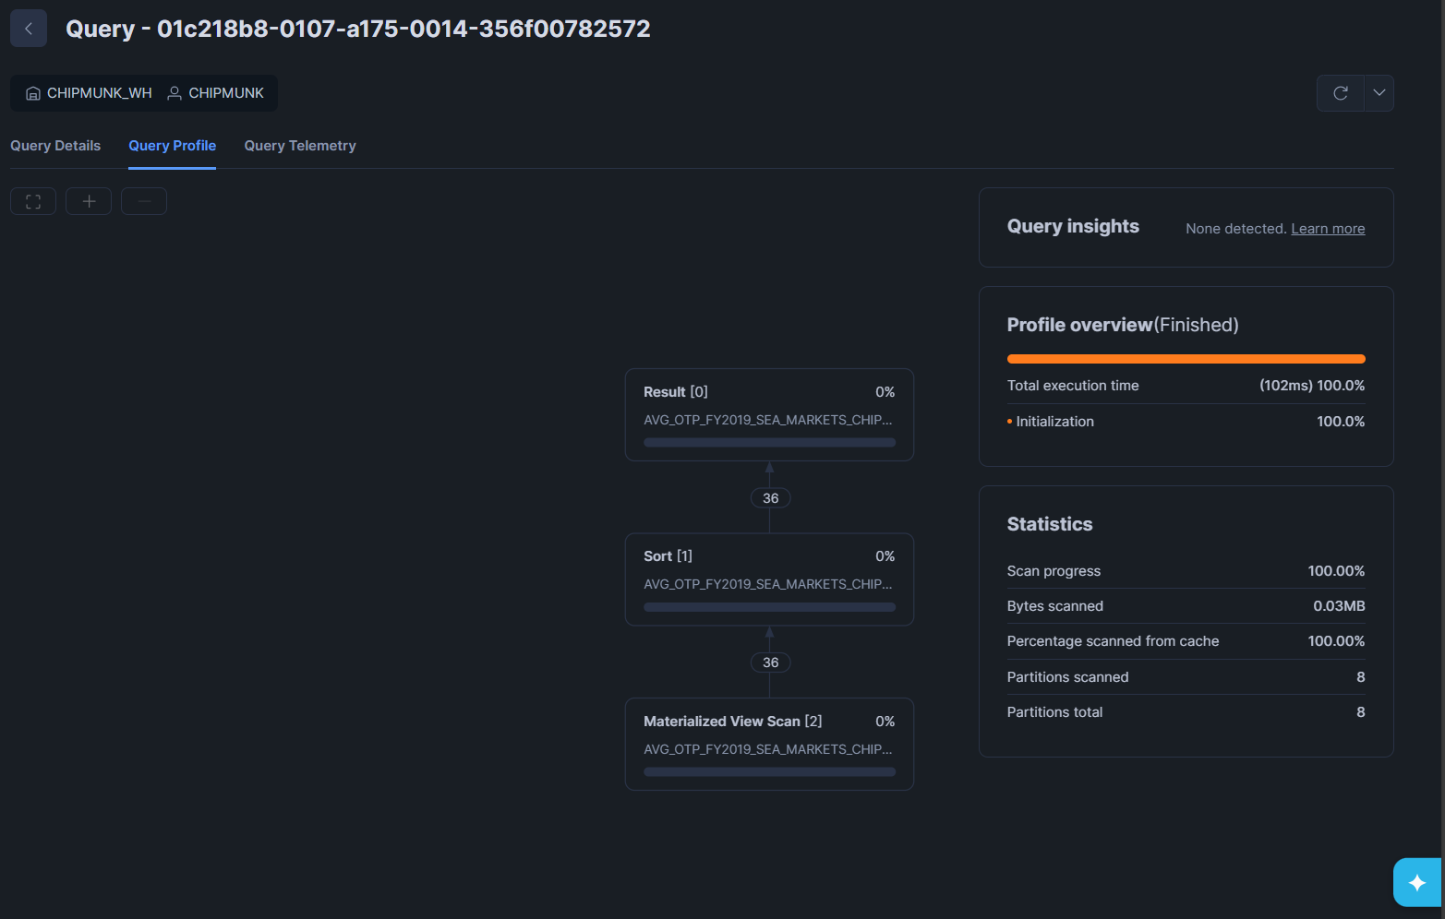

Explaination/Overview:
In the standard view, snowflake had to execute a filter and an aggregation on all the rows before sorting the data. However, in the materialized view, these steps are gone. This is because the view has already materialized the sum and filtered the data, hence the query simply reads the small and pre-calculated result to performs a final sort. Therefore, it resulted standard view having a 12 seconds execution time and about 836.74 MB external bytes scanned, which is 69/234 of partition. However, querying the materialized view have an execution time of only 576 milliseconds and about 0.03 MB external bytes scanned, which is 8/8 of partition. This shows that materialized view has an overall better performance.

Step 10: Explore and implement additional granular partitioning schemes and demonstrate their impact on query performance.
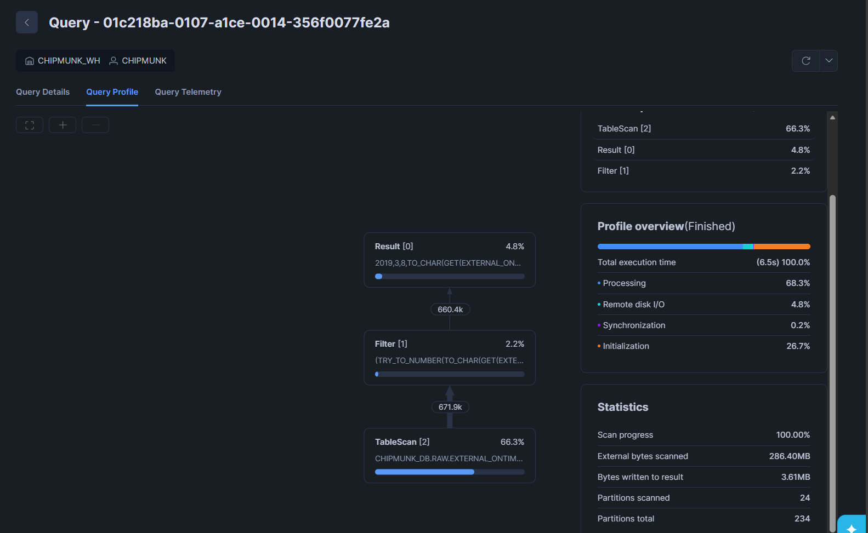

Explaination/Overview
The execution time of the granular partition is by far the fastest as compared to both partition and no partition with a speed of 6.5s, this means that it shows the best performance boost. Additionally, it only scanned 24 partitions out of 234, with also 286.40 MB of external bytes scanned. It shows that granular partition significantly reduces the number of files scanned and improves query performance when filtering on month-level predicates as when filtering by a specific month, Snowflake can eliminate entire folders at the metadata level before reading any data files, resulting in significantly fewer files scanned and reduced I/O, demonstrating effective partition pruning benefits.

Question 2 (25 Marks) – Individual

Step 1: Create a new worksheet “Jayden Tee DLW ASG – Part B Q2”
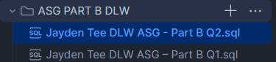

Step 2: Set Context and Suspend Warehouse
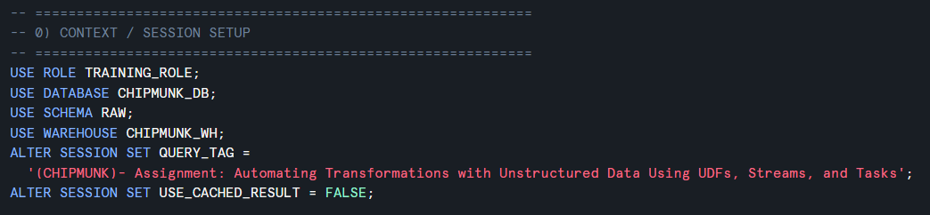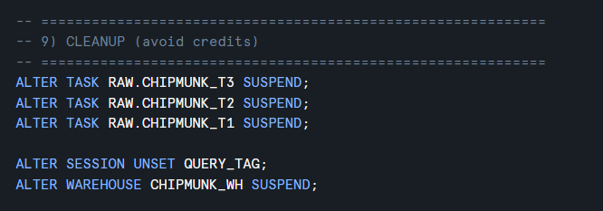

Step 3: Understanding the purpose
This pipeline automates the ingestion and processing of unstructured PDF documents stored in a Snowflake internal stage. It uses a DIRECTORY listing, a stage stream, a table stream, a Python UDF (PyPDF2) for text extraction, and a task DAG to process only newly-arrived PDFs incrementally.
The final MODELED views integrate three sources:
• Parsed PDF text and metadata (from the PROCESSED catalog table)
• Curated product feedback dataset (Part A curated table)
• External table statistics from Part B Qn 1 (partitioned vs non-partitioned) to demonstrate partition pruning performance.

Step 4: Pipeline Architecture (objects created)
Object Type | Name | Purpose
Stage (Internal) | RAW.CHIPMUNK_PDF_INT_STAGE | Stores uploaded PDFs; DIRECTORY() is enabled for listing.
Stage Stream | RAW.CHIPMUNK_PDF_STAGE_STREAM | Captures new file events (INSERT) on the stage.
RAW Table | RAW.CHIPMUNK_PDF_RAW_FILE_CATALOG | Stores file metadata + scoped URL checkpoint (no parsing here).
Table Stream | RAW.CHIPMUNK_PDF_STAGE_STREAM_T2 | Captures new rows inserted into RAW table (incremental trigger for T2).
PROCESSED Table | RAW.CHIPMUNK_PDF_PROCESSED_FILE_CATALOG | Stores extracted text + PDF metadata for analytics.
Python UDF | RAW.CHIPMUNK_GET_PDF_PAYLOAD() | Reads PDF via scoped URL; extracts metadata, page_count, full text.
Task | RAW.CHIPMUNK_T1 | Refresh stage + insert new RAW metadata rows.
Task | RAW.CHIPMUNK_T2 | Parse new RAW rows using UDF; insert into PROCESSED.
Task | RAW.CHIPMUNK_T3 | Create MODELED views (PART vs NOPART) for performance comparison.
MODELED View | MODELED.CHIPMUNK_FINAL_INTEGRATED_PART | Uses partitioned external table for partb_stats (better pruning).
MODELED View | MODELED.CHIPMUNK_FINAL_INTEGRATED_NOPART | Uses non-partitioned external table for partb_stats (baseline).

Step 5: The task DAG Flow (T1 -> T2 -> T3)
The pipeline is implemented as a task DAG with clear separation of responsibilities:
• T1 (serverless): detects new PDFs and writes only metadata to the RAW catalog table.
• T2 (warehouse): reads only newly inserted RAW rows (via table stream), runs the Python UDF, and writes parsed output to PROCESSED.
• T3 (serverless): builds MODELED views for reporting and partition-pruning comparison.
The process:
Task | Compute | Trigger Condition | Key Output
RAW.CHIPMUNK_T1 | Serverless | Runs every 1 minute (schedule) | Inserts new RAW metadata rows
RAW.CHIPMUNK_T2 | CHIPMUNK_WH | SYSTEM$STREAM_HAS_DATA(RAW.CHIPMUNK_PDF_STAGE_STREAM_T2) | Inserts parsed rows into PROCESSED
RAW.CHIPMUNK_T3 | Serverless | Runs AFTER T2 completes | Creates MODELED views (PART / NOPART)

Step 6: The key implementation details
- Python UDF
T1 generates a scoped URL using BUILD_SCOPED_FILE_URL(@stage, relative_path). T2 passes this scoped URL into the Python UDF, which uses SnowflakeFile.open() to read the PDF securely from the stage.

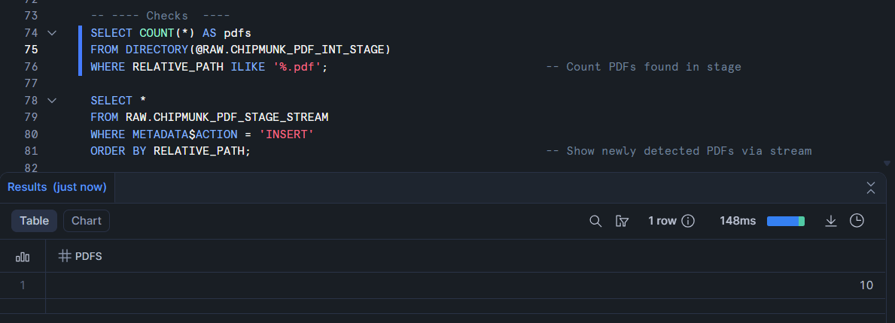
Figure 1. Showing the PDFs is inside @RAW.CHIPMUNK_PDF_INT_STAGE

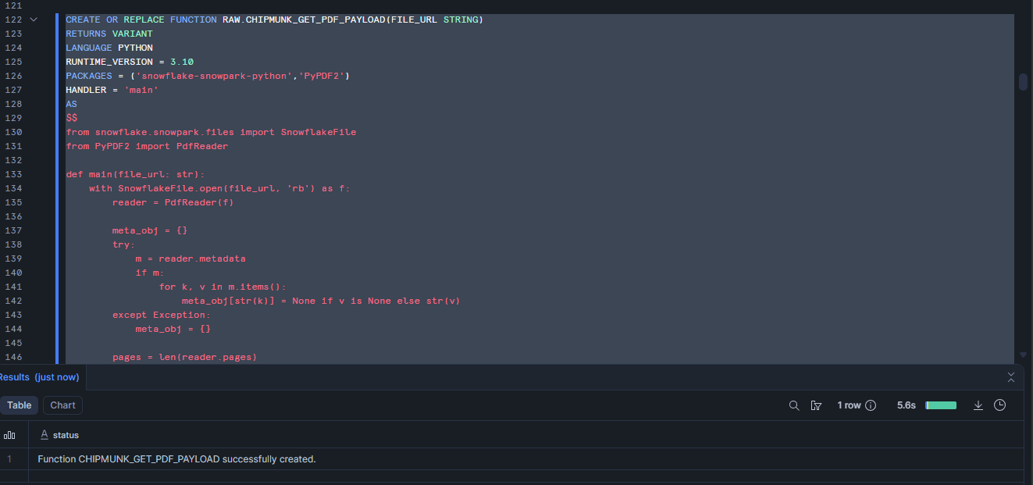
Figure 2. Showing that UDF is deployed

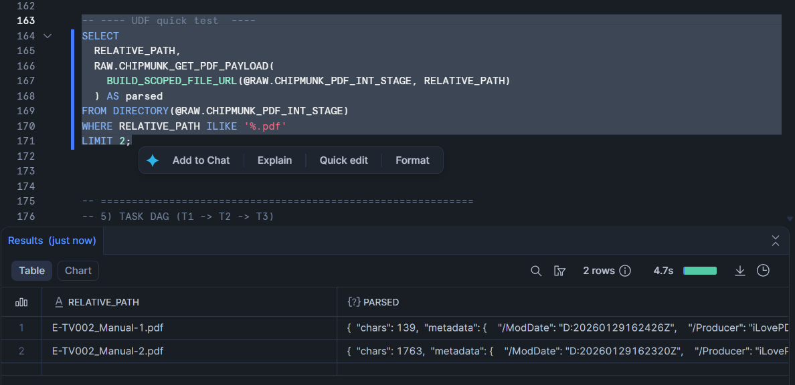
Figure 3. Showing that UDF works

- Incremental Parsing Using Streams
The stage stream records new file events (METADATA$ACTION='INSERT'). T1 writes one RAW row per new PDF. The table stream on RAW.CHIPMUNK_PDF_RAW_FILE_CATALOG then records those inserts. T2 only parses the rows present in the table stream, preventing reprocessing of older PDFs.
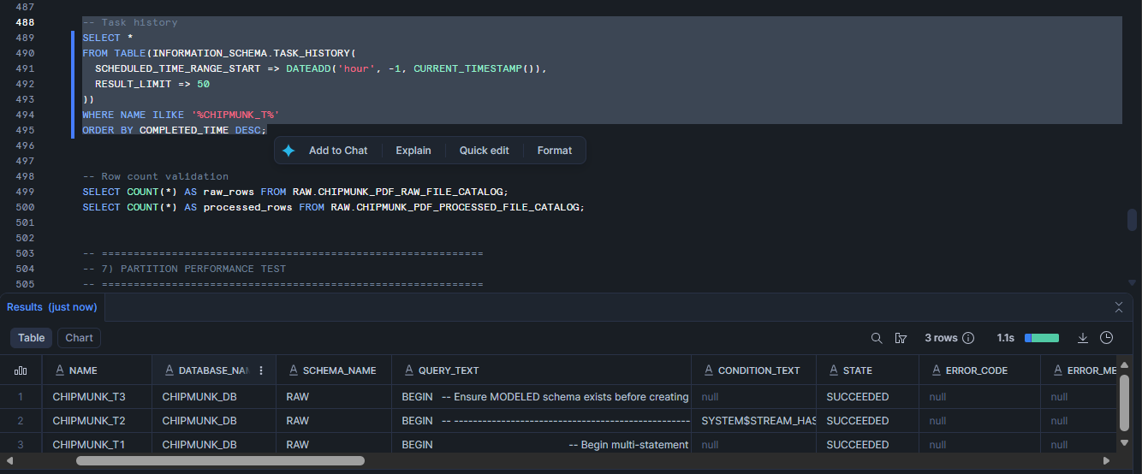
Figure 4. Task history showing all task working

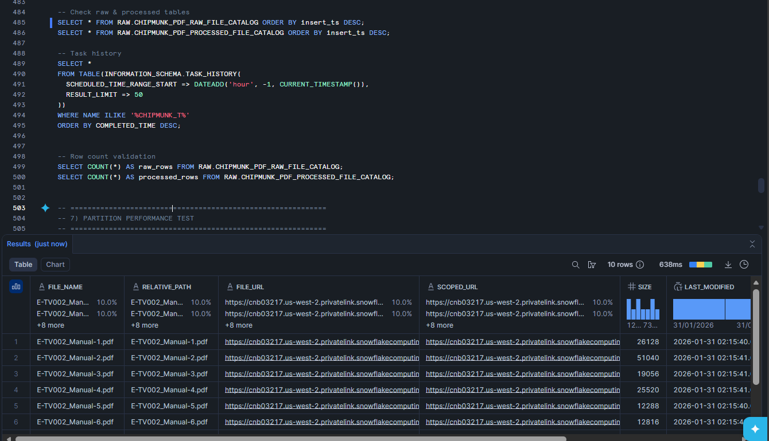
Figure 5. Showing that T1 works and insert data in metadata

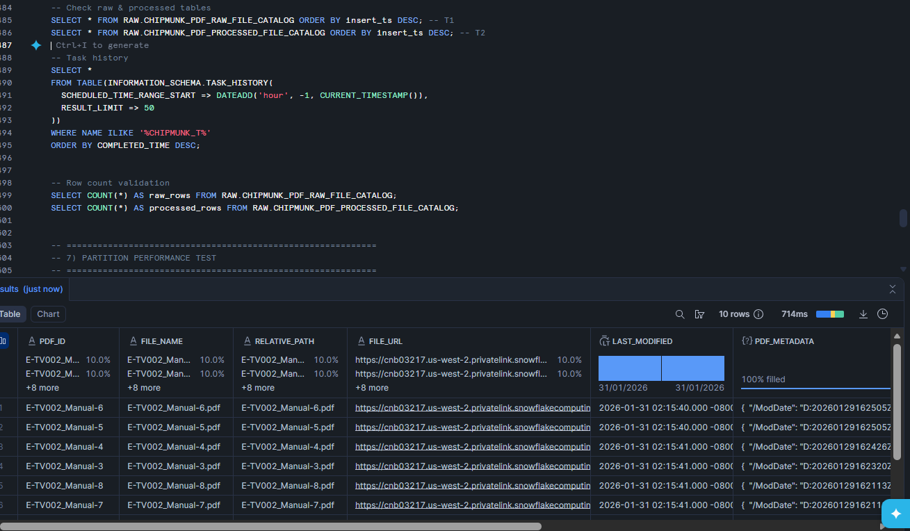
Figure 6. Showing that T2 works and inserts the parsed data

- External Table Stats (PART vs NOPART)
Both final views compute partb_stats (avg_arr_delay, cancel_rate) for year=2019 and quarter=3. The PART view reads from the partitioned external table (RAW.EXTERNAL_ONTIME_ASG_CHIPMUNK_PART), enabling partition pruning. The NOPART view reads from RAW.EXTERNAL_ONTIME_ASG_CHIPMUNK_NOPART, which typically scans more data.
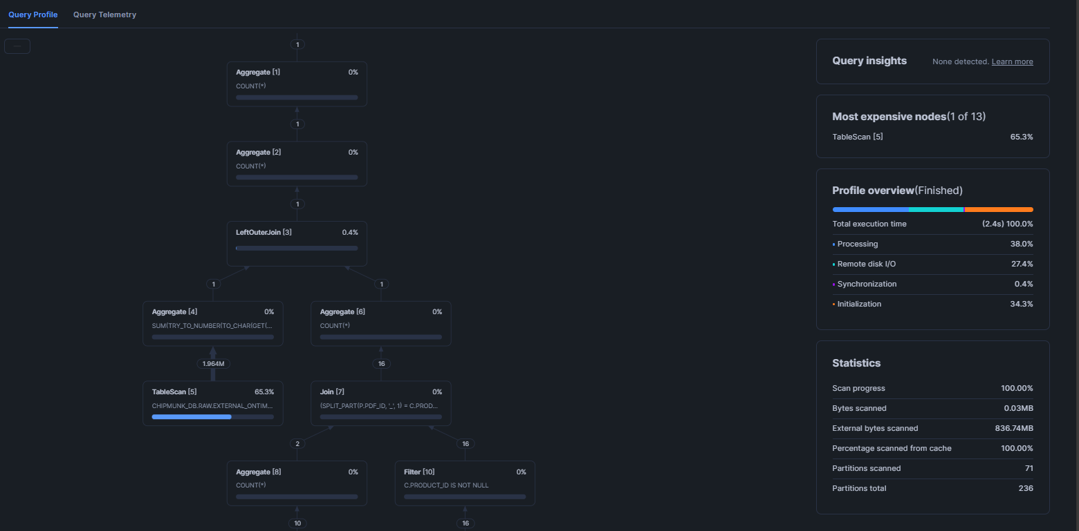
Figure 7. Showing partition query profile

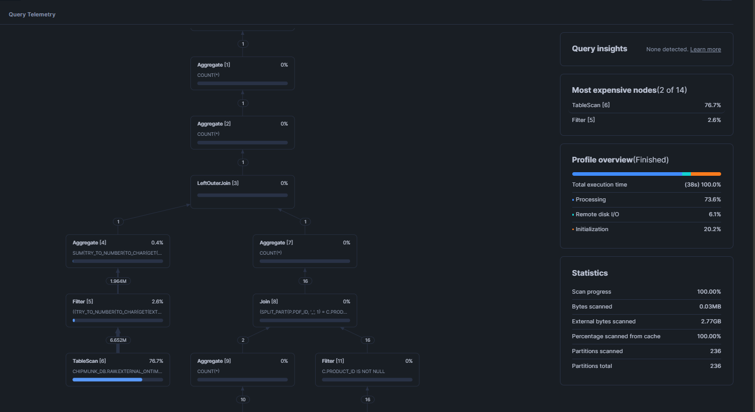
Figure 8. Showing non-partition query profile

What does it mean? (Non-partition vs partition):

1) Non-partition view
Key numbers:
- Total execution time: 38s
- External bytes scanned: 2.77 GB
- Partitions scanned: 236 / 236 (i.e., no pruning happened)
- Most expensive node: TableScan ~76.7%, the query is dominated by scanning the external table files
Meaning:
- Because the external table is not partitioned, Snowflake can’t skip folders/files early.
- Even though the query filters to year=2019 and quarter=3, Snowflake still ends up scanning everything which are all the partitions, then filtering after.

2) Partition view
Key numbers:
- Total execution time: 2.4s
- External bytes scanned: 836.74 MB
- Partitions scanned: 71 / 236 (i.e., 165 partitions pruned)
- Most expensive node: TableScan ~65.3%, still scan-heavy, but scanning far less data
Meaning:
- Because the external table is partitioned by folders like year=.../quarter=..., Snowflake can use your filter to skip irrelevant partitions.
- It only reads the partitions that match the filter.
Conclusion on comparison views
The partitioned external table demonstrates effective partition pruning, where the query scanned 71/236 partitions and 836.74 MB external data versus the non-partitioned table scanning 236/236 partitions and 2.77 GB. This reduced scan workload led to a significant runtime improvement from 2.4s in partition view vs 38s in non-partition view, confirming that partitioning improves performance by skipping irrelevant files early in query execution. Hence, we would use partition view as our finalized view model.

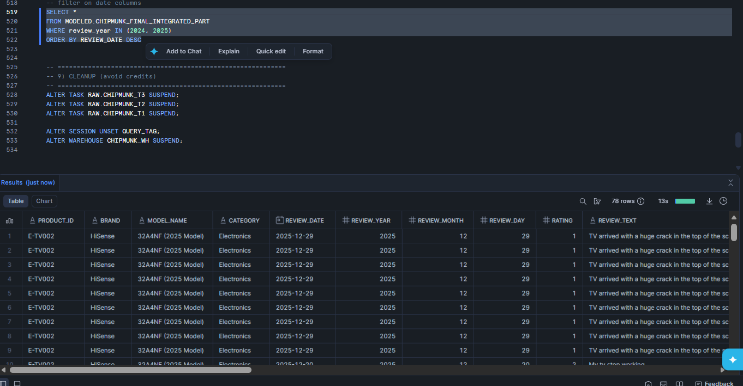
Figure 9. Finalized integrated model using partition view.

Step 7: Challenges encountered

Here are some of the challenges I encountered while doing this assignment:

- Curated join columns were NULL:
Root cause: pdf_id included suffixes like '_Manual-1' while curated PRODUCT_ID was only 'E-TV002'.
How I fix it: join using SPLIT_PART(p.pdf_id, '_', 1).
- T2 skipped even when files existed:
Root cause: streams only contain new changes since creation/last consumption, hence if PDFs were uploaded before stream creation, stream can be empty.
How I fix it: I refresh stage after stream creation, then re-upload or I tired to add a new file to generate INSERT events. Additionally, I made sure to just add it after creating my stages.
- Duplicates on reruns:
Root cause: scheduled tasks can retry or stream events may replay.
How I fix it: I added NOT EXISTS checks on (relative_path, last_modified) for both RAW and PROCESSED inserts so as to prevent any duplication.
- SQL compilation / script issues:
Examples: missing semicolons or trailing commas in SELECT lists can produce compilation errors or even BEGIN.
How I fix it: I ensure every standalone SELECT ends with ';' and remove trailing commas and also make sure that there is END when I use BEGIN.

